**Preliminary Results Summary**

Notes:

* Prices and expenditures used in the calculations are all deflated to December 2018 prices using the consumer prices index for tobacco.
* Upshift factor was calculated using Howard Reeds methodology and comparing expenditures implied by HMRC returns to grossed up spending in the toolkit data.
  + Also have some results using Howards figure (2.59) and Maries (1.57). My estimate is 1.90
* Income measure is disposable income after housing costs.

**Fig 1a) Smoking Prevalence and Income**

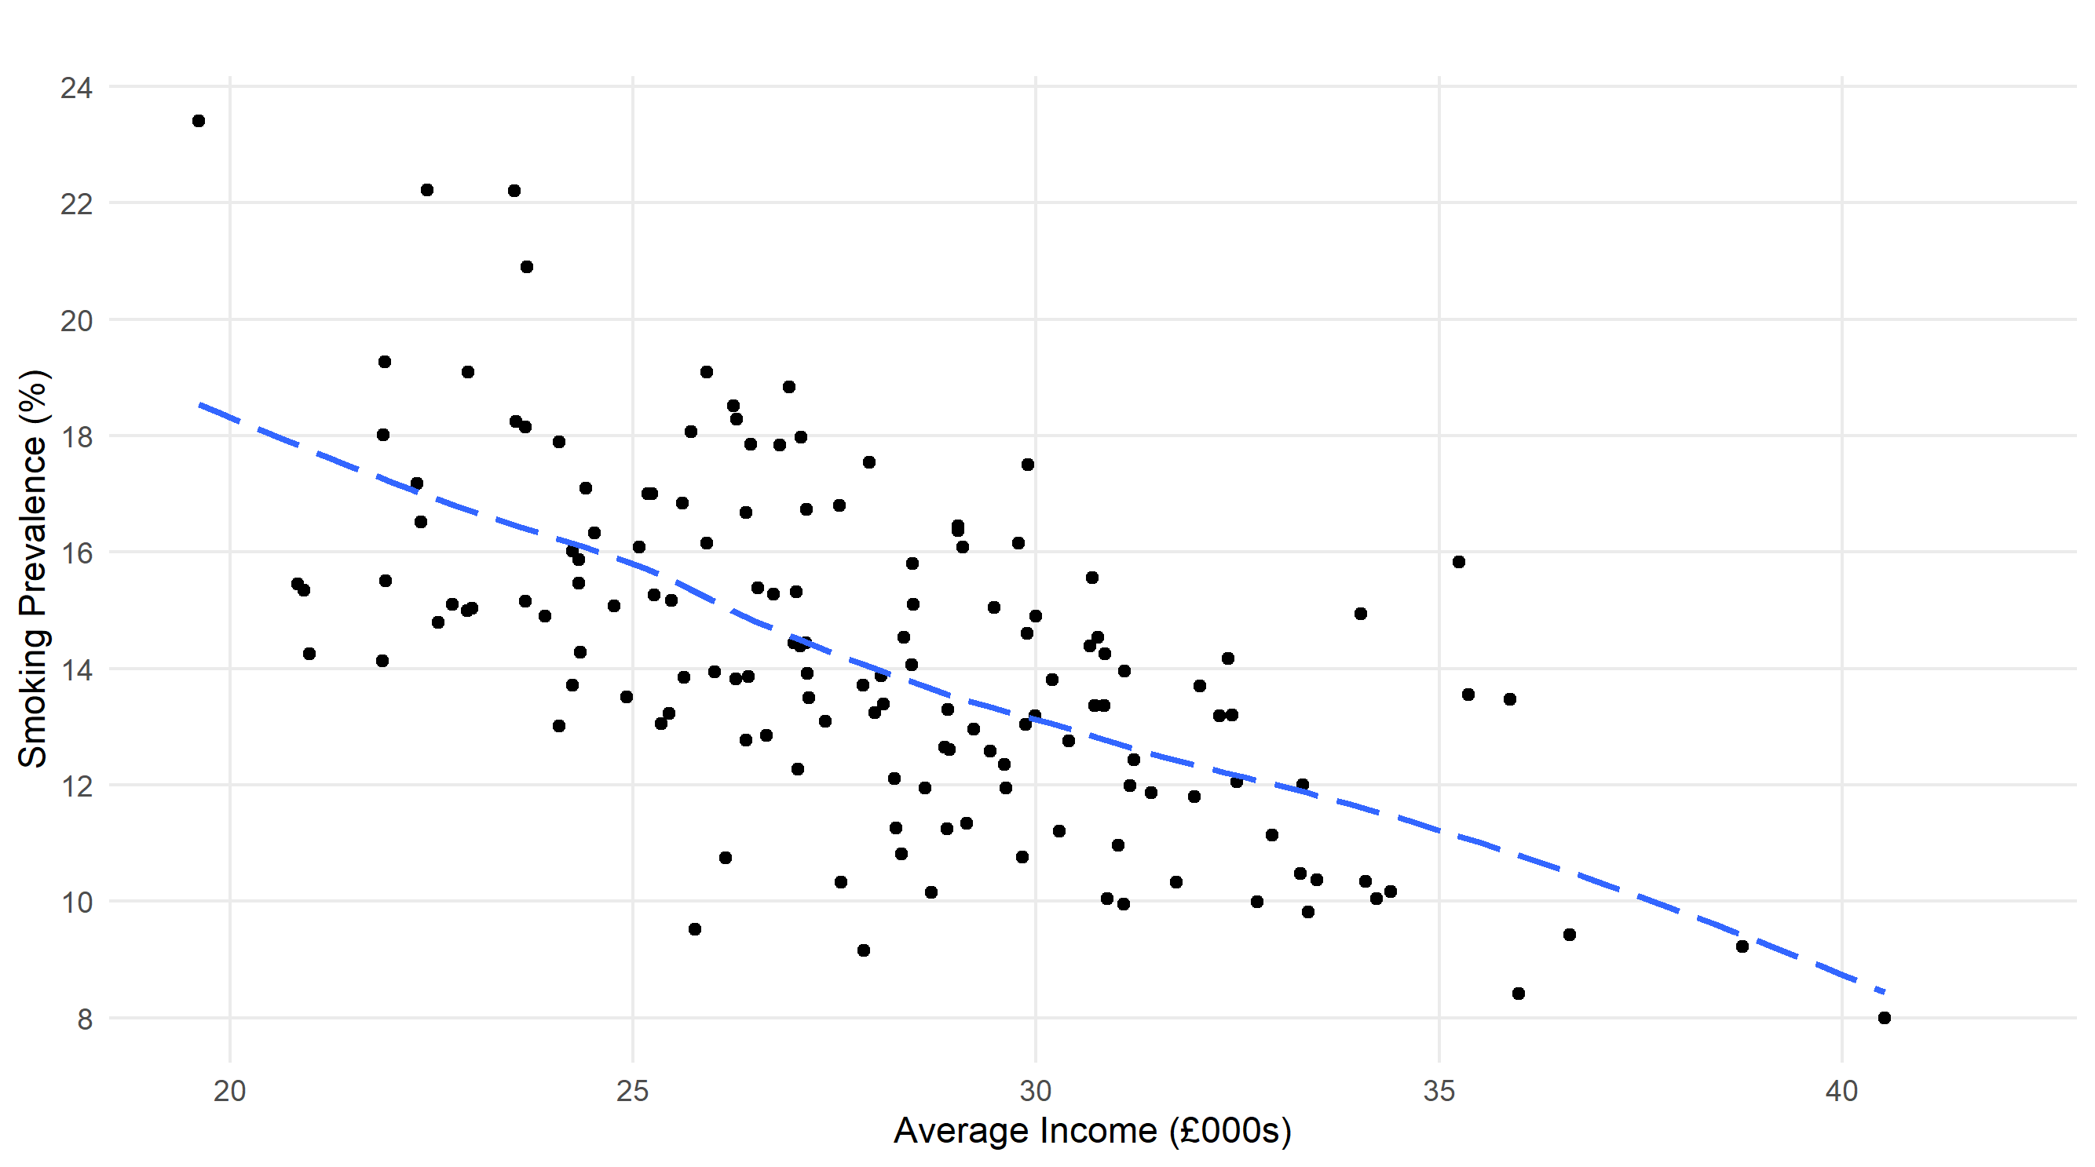

Clear negative correlation between local authority average income and smoking prevalence – higher proportion of smokers in low-income areas.

**Fig 1b) Smoking Prevalence and Income – by region**

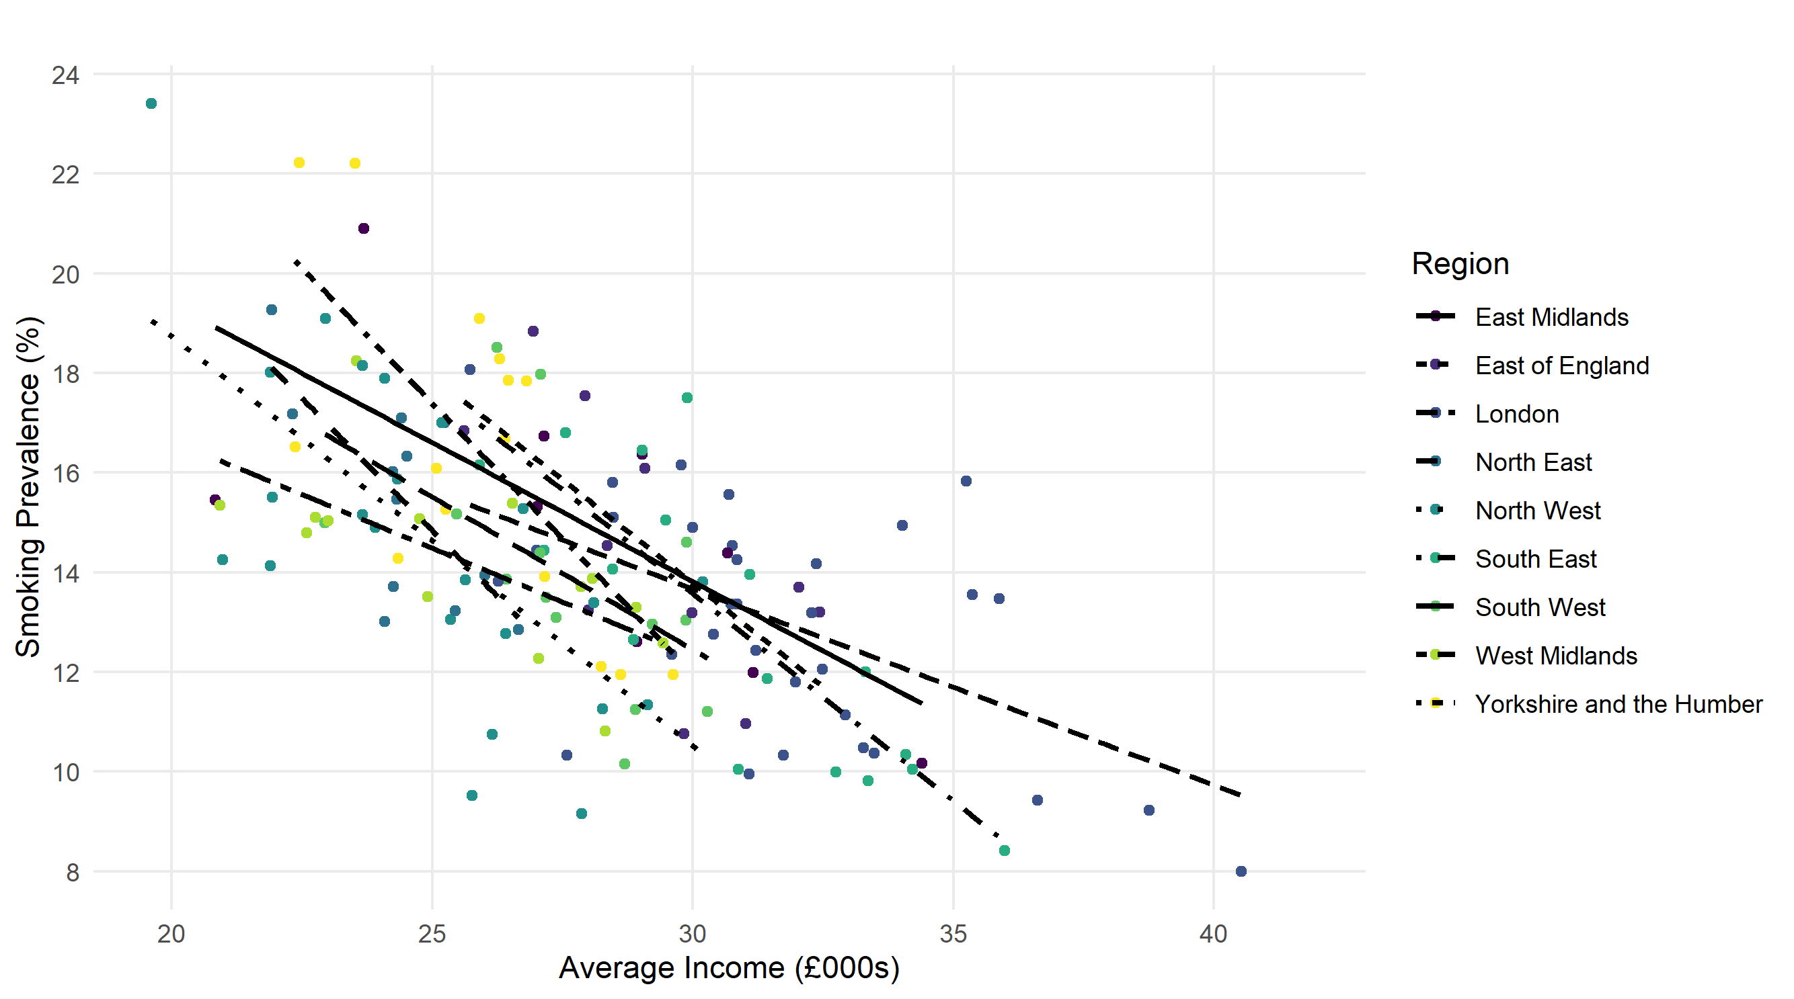

This correlation also holds up within regions

**Fig 2) Upshifted Smoking Expenditure and Income**

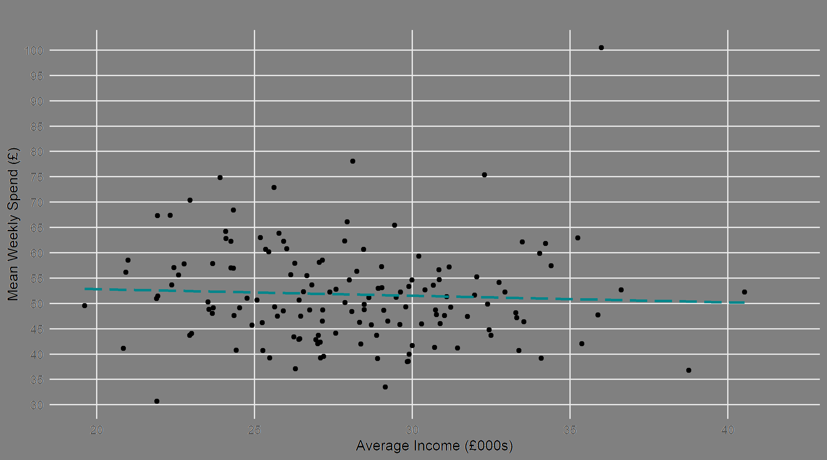

The same correlation doesn’t exist when looking at mean weekly spending…

**Fig 3) Upshifted Smoking Expenditure (% of Income) and Income**

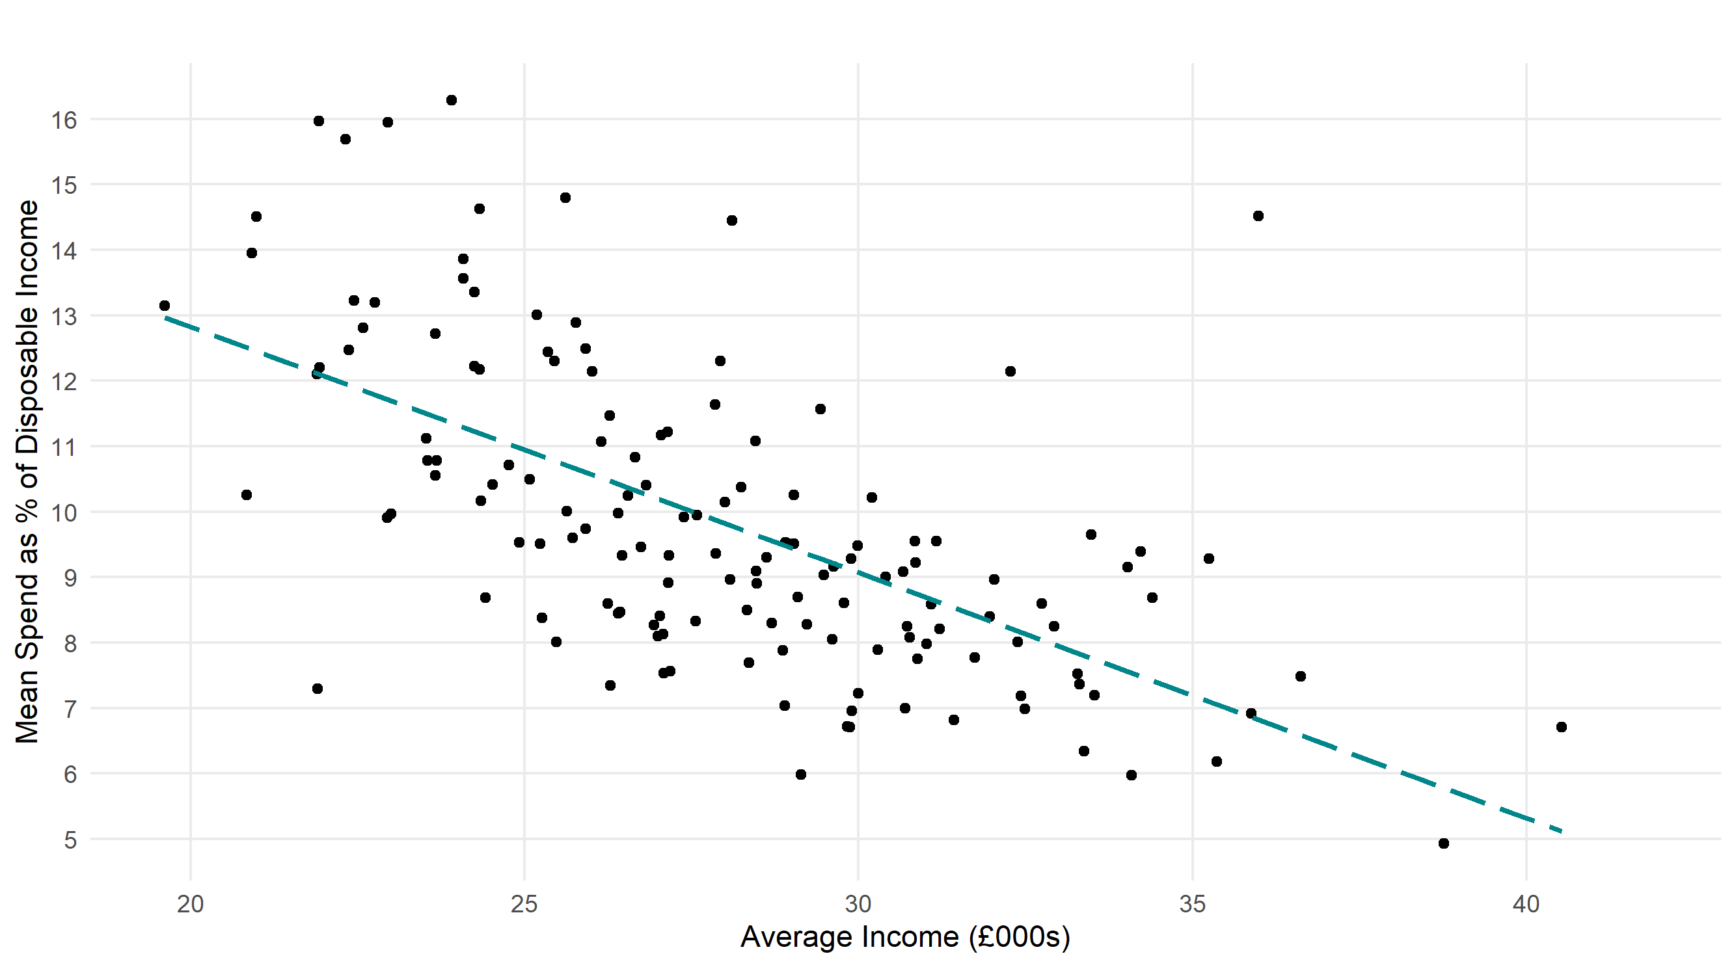

… implying figure 3, which shows that lower income areas tend to spend a greater proportion of their disposable income on tobacco products.